Great Dodecahedron

Definition
# Source: AI Source: Provided by: [Data Path: Persons Table -> ID Column: 1, Name_En Column: Motasem Essam] -> From: [ChatGPT] on [7/25/2026]
The Great Dodecahedron is a regular non-convex polyhedron belonging to the four classical Kepler–Poinsot Polyhedra.
It consists of 12 regular pentagonal faces that intersect one another in a star-like arrangement. Five pentagonal faces meet at each vertex, following a pentagrammic vertex arrangement.
Its Schläfli symbol is:
$$\boxed{\{5,\frac{5}{2}\}}$$
Where:
- $5$ represents the regular pentagonal faces.
- $5/2$ represents the pentagrammic arrangement of faces around each vertex.
Unlike the Small Stellated Dodecahedron, which has pentagrammic faces, the Great Dodecahedron has ordinary regular pentagonal faces. Its star-like geometry results from the way those faces intersect.

Geometric Representation
# Source: AI Source: Provided by: [Data Path: Persons Table -> ID Column: 1, Name_En Column: Motasem Essam] -> From: [ChatGPT] on [7/25/2026]
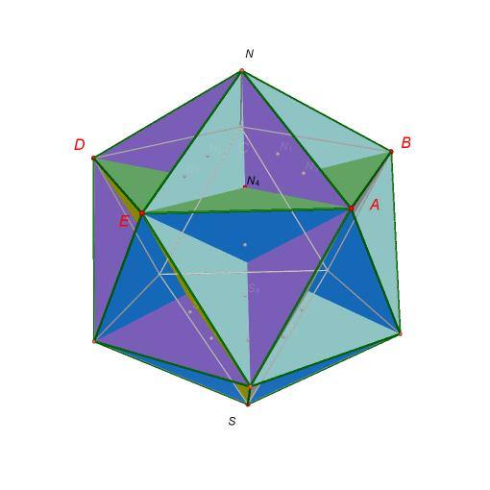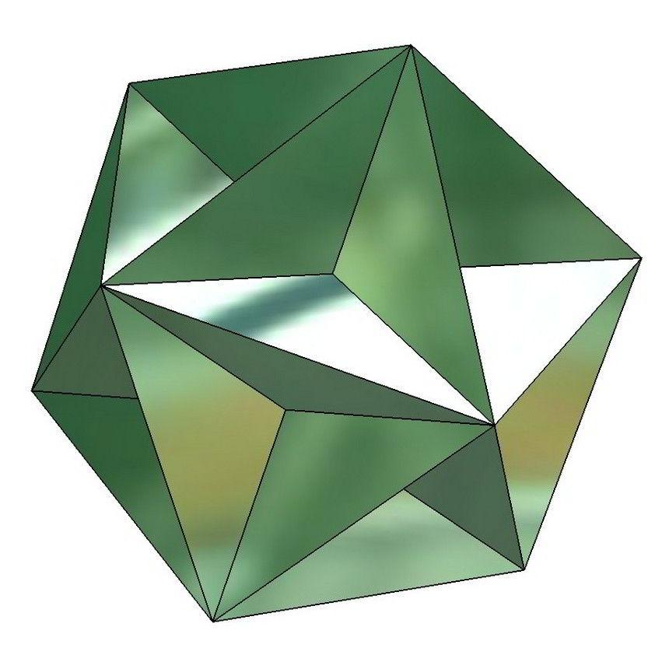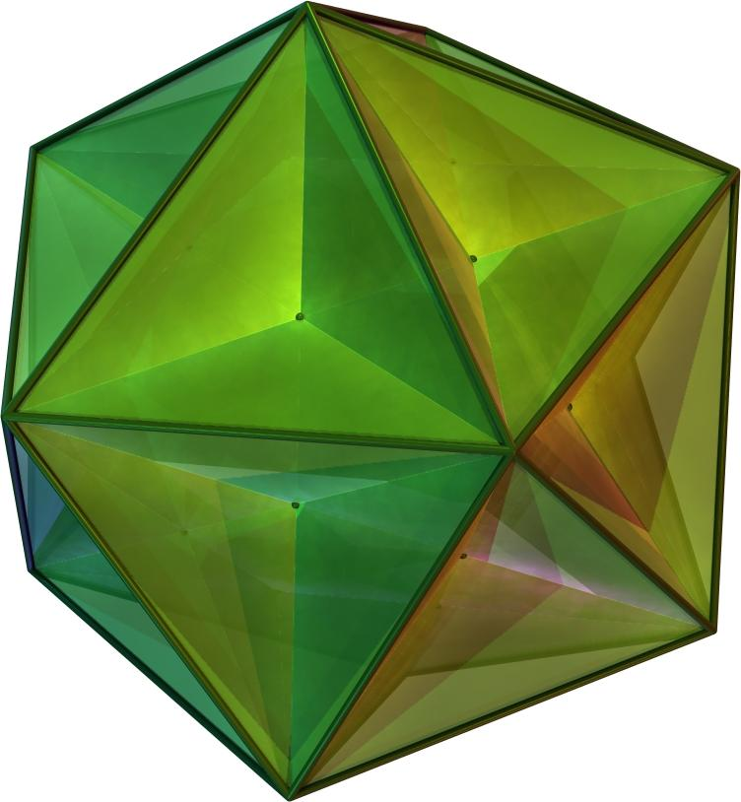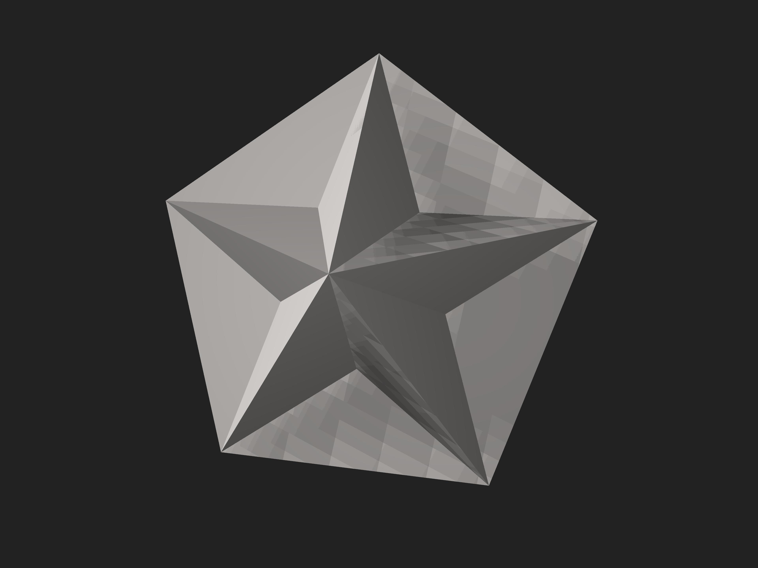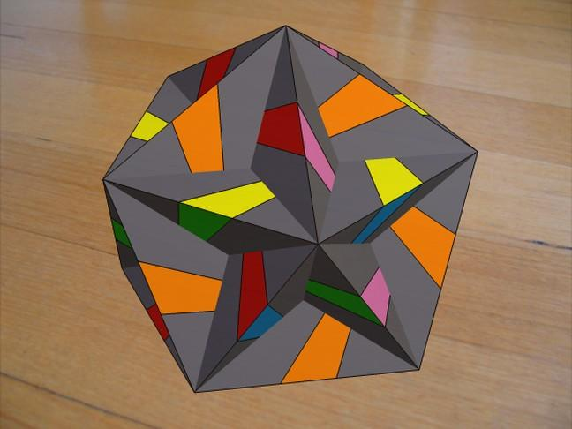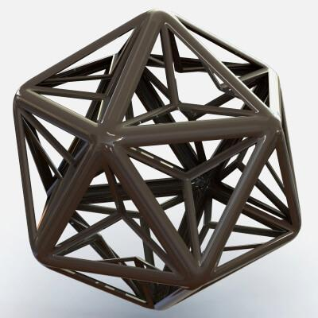

Geometric Structure
# Source: AI Source: Provided by: [Data Path: Persons Table -> ID Column: 1, Name_En Column: Motasem Essam] -> From: [ChatGPT] on [7/25/2026]
The Great Dodecahedron has a symmetrical star-like structure formed by 12 intersecting pentagonal faces.
Its structure includes:
- Pentagonal Faces: Twelve regular pentagons arranged in a non-convex configuration.
- Edges: Thirty edges forming the boundaries of the pentagonal faces.
- Vertices: Twelve vertices arranged in the same positions as the vertices of a regular icosahedron.
- Intersecting Faces: The pentagonal faces pass through one another in space.
- Pentagrammic Vertex Arrangement: Five faces meet at each vertex in a star-shaped arrangement.
- Internal Regions: Some portions of the pentagonal faces extend through the interior of the overall structure.

Mathematical Properties
# Source: AI Source: Provided by: [Data Path: Persons Table -> ID Column: 1, Name_En Column: Motasem Essam] -> From: [ChatGPT] on [7/25/2026]
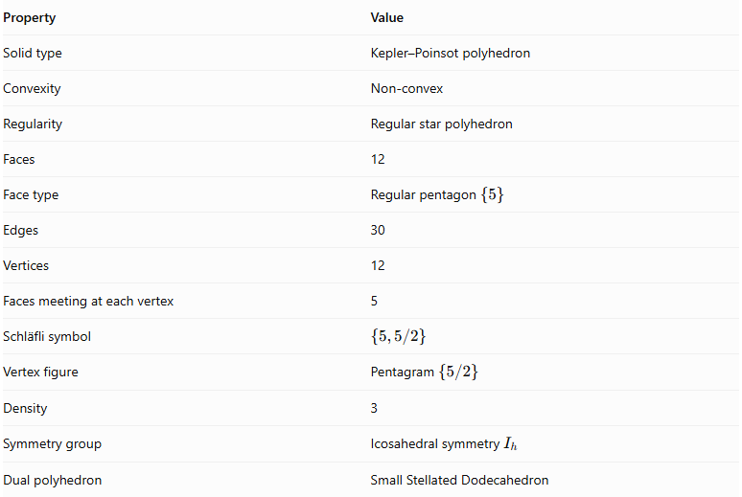
Property | Value
Solid type | Kepler–Poinsot polyhedron
Convexity | Non-convex
Regularity | Regular star polyhedron
Faces | 12
Face type | Regular pentagon $\{5\}$
Edges | 30
Vertices | 12
Faces meeting at each vertex | 5
Schläfli symbol | $$\{5,5/2\}$$
Vertex figure | Pentagram $\{5/2\}$
Density | 3
Symmetry group | Icosahedral symmetry $I_{h}$
Dual polyhedron | Small Stellated Dodecahedron

Face Composition
# Source: AI Source: Provided by: [Data Path: Persons Table -> ID Column: 1, Name_En Column: Motasem Essam] -> From: [ChatGPT] on [7/25/2026]
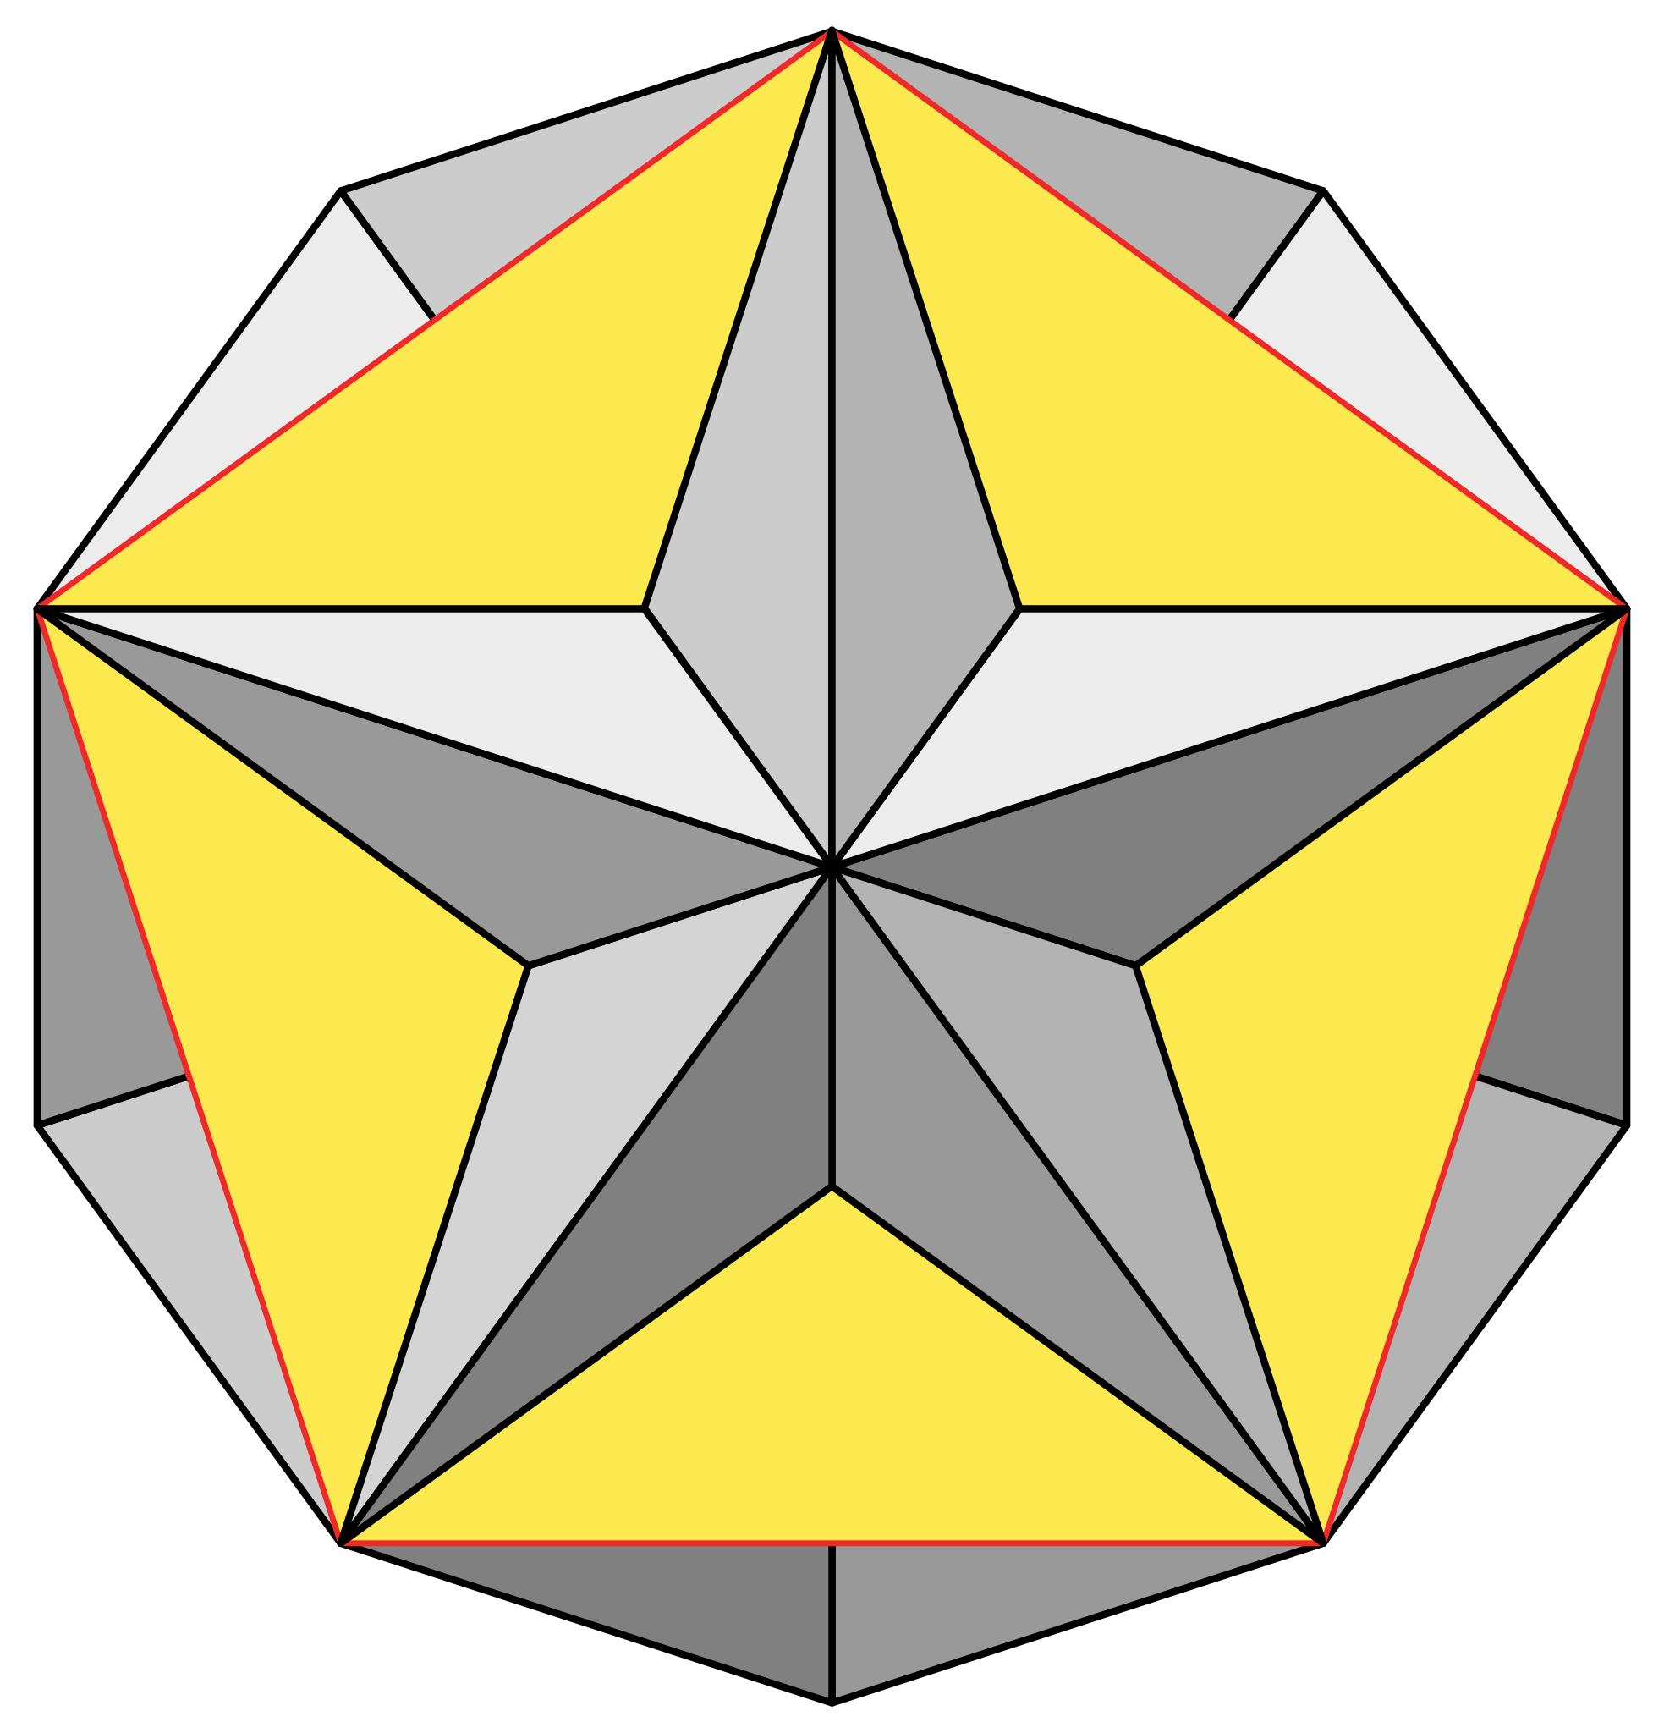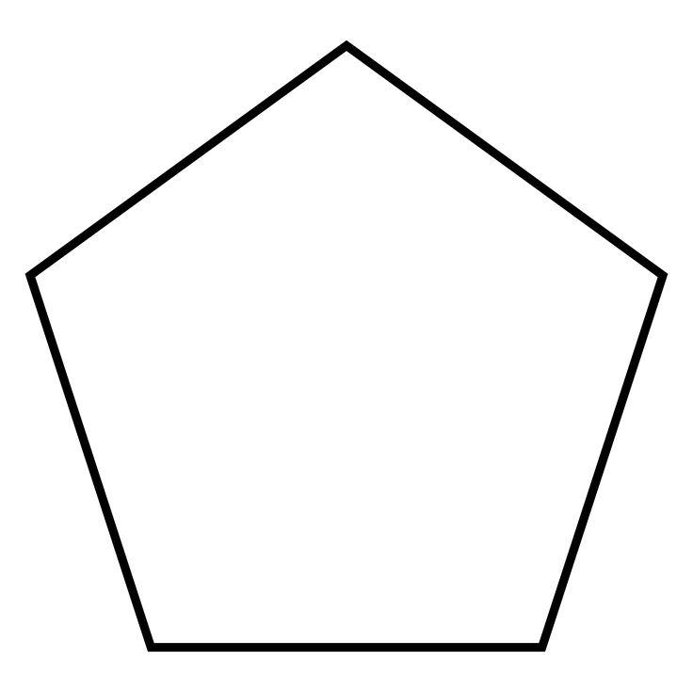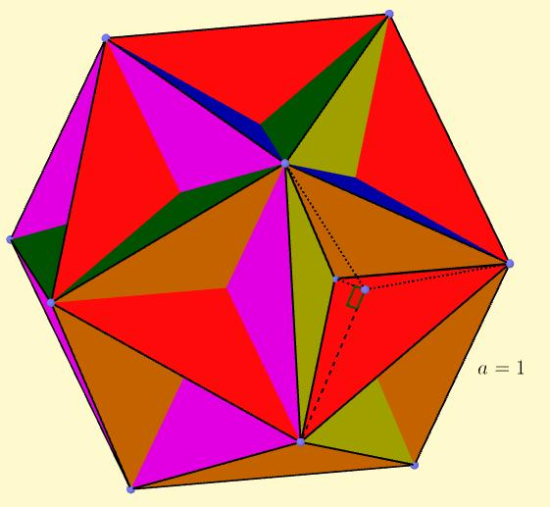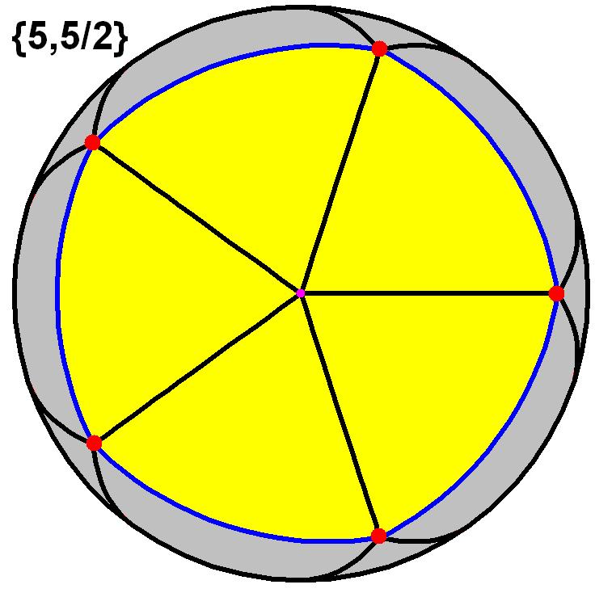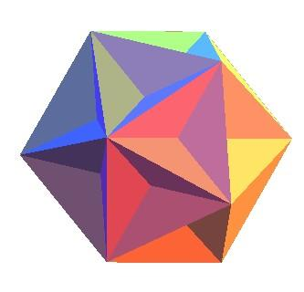
The Great Dodecahedron is composed entirely of regular pentagonal faces.
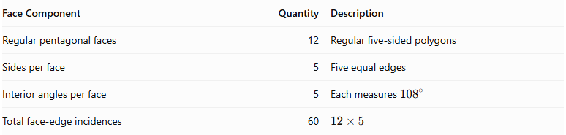
Face Component | Quantity | Description
Regular pentagonal faces | 12 | Regular five-sided polygons
Sides per face | 5 | Five equal edges
Interior angles per face | 5 | Each measures ${108}^{∘}$
Total face-edge incidences | 60 | $$12×5$$
Important: Each pentagon is counted as one face. The intersections between faces do not turn the pentagons into separate triangular or smaller polygonal faces under the conventional Kepler–Poinsot counting system.

Vertex Configuration
# Source: AI Source: Provided by: [Data Path: Persons Table -> ID Column: 1, Name_En Column: Motasem Essam] -> From: [ChatGPT] on [7/25/2026]
Five pentagonal faces meet at each vertex.
The vertex figure is a pentagram:
$$\boxed{\{\frac{5}{2}\}}$$
This means that the five surrounding faces have a star-like cyclic arrangement rather than the ordinary convex arrangement found in a regular dodecahedron.
The 12 vertices occupy the same positions as the vertices of a regular icosahedron.

Construction
# Source: AI Source: Provided by: [Data Path: Persons Table -> ID Column: 1, Name_En Column: Motasem Essam] -> From: [ChatGPT] on [7/25/2026]
One construction method is to create the Great Dodecahedron by faceting a regular icosahedron.
Construction steps:
- Begin with a regular icosahedron containing 12 vertices, 30 edges, and 20 triangular faces.
- At each vertex, identify its five neighboring vertices.
- Connect those five neighboring vertices in the appropriate pentagrammic order to form a regular pentagon.
- Repeat this procedure for all 12 vertices of the icosahedron.
- Use the resulting 12 pentagonal faces to form the Great Dodecahedron.
- Preserve the intersecting arrangement of the faces rather than replacing it with a convex outer hull.
This construction produces a polyhedron with the same vertices and edge graph as the icosahedron, but with a different arrangement of faces.

Geometric Dimensions and Formulas
# Source: AI Source: Provided by: [Data Path: Persons Table -> ID Column: 1, Name_En Column: Motasem Essam] -> From: [ChatGPT] on [7/25/2026]
Let $a$ represent the edge length of each regular pentagonal face.

Interior Angle of Each Face
# Source: AI Source: Provided by: [Data Path: Persons Table -> ID Column: 1, Name_En Column: Motasem Essam] -> From: [ChatGPT] on [7/25/2026]
Each face is a regular pentagon.
$$θ=\frac{(5-2){180}^{∘}}{5}$$
$$\boxed{θ={108}^{∘}}$$

Face Area
# Source: AI Source: Provided by: [Data Path: Persons Table -> ID Column: 1, Name_En Column: Motasem Essam] -> From: [ChatGPT] on [7/25/2026]
The area of one regular pentagonal face is:
$$A_{f}=\frac{a^{2}}{4}\sqrt{25+10\sqrt{5}}$$
Since there are 12 faces, the conventional sum of their individual areas is:
$$S_{faces}=12A_{f}$$
$$\boxed{S_{faces}=3a^{2}\sqrt{25+10\sqrt{5}}}$$
This is the sum of the 12 pentagon areas, not necessarily the area of a non-overlapping external boundary.

Volume
# Source: AI Source: Provided by: [Data Path: Persons Table -> ID Column: 1, Name_En Column: Motasem Essam] -> From: [ChatGPT] on [7/25/2026]
The Great Dodecahedron is self-intersecting. Therefore, its volume must be interpreted using a specified convention, such as signed volume or density-weighted volume. A simple convex-solid volume formula should not be applied without defining that convention.

Euler Characteristic
# Source: AI Source: Provided by: [Data Path: Persons Table -> ID Column: 1, Name_En Column: Motasem Essam] -> From: [ChatGPT] on [7/25/2026]
The Great Dodecahedron has:
- $V=12$ vertices.
- $E=30$ edges.
- $F=12$ faces.
Using the conventional counts:
$$chi=V-E+F$$
$$chi=12-30+12$$
$$\boxed{chi=-6}$$
This differs from the Euler characteristic of an ordinary convex polyhedron, which is 2. The difference is associated with the self-intersecting geometry and the conventional face and edge counting of this regular star polyhedron.

Density
# Source: AI Source: Provided by: [Data Path: Persons Table -> ID Column: 1, Name_En Column: Motasem Essam] -> From: [ChatGPT] on [7/25/2026]
The density of the Great Dodecahedron is:
$$\boxed{D=3}$$
Density describes the number of times the oriented polyhedral surface covers a generic point or direction relative to its center, taking account of the intersections of its faces.
The Great Dodecahedron and Small Stellated Dodecahedron both have density 3.

Constructing a Great Dodecahedron

Geometric Instruments
# Source: AI Source: Provided by: [Data Path: Persons Table -> ID Column: 1, Name_En Column: Motasem Essam] -> From: [ChatGPT] on [7/25/2026]

- Ruler / Straightedge: Drawing pentagonal edges, icosahedral edges, and construction lines.
- Compass: Constructing regular pentagons, equilateral triangles, and transferring equal lengths.
- Protractor: Measuring pentagonal angles and checking geometric inclinations.
- Set Squares: Drawing perpendicular and parallel construction lines.
- Pencil: Drawing outlines, diagonals, and construction marks.
- Eraser: Removing unnecessary construction lines.
- Cardboard or Construction Paper: Preparing the pentagonal face components for a physical model.
- Scissors and Adhesive: Cutting and assembling the model components.

Instrument-Based Construction Procedures

Method 1: Construction by Faceting a Regular Icosahedron
# Source: AI Source: Provided by: [Data Path: Persons Table -> ID Column: 1, Name_En Column: Motasem Essam] -> From: [ChatGPT] on [7/25/2026]
- Construct a regular icosahedron with 20 equilateral triangular faces.
- Identify its 12 vertices.
- At each vertex, identify the five neighboring vertices connected to it by icosahedral edges.
- Mark these five neighboring vertices as a group.
- Connect the five vertices consecutively in their cyclic order to form a regular pentagon.
- Repeat the procedure around all 12 vertices of the icosahedron.
- Verify that the construction produces 12 pentagonal faces.
- Check that each pentagonal face uses five vertices of the original icosahedron.
- Darken the 30 true edges and distinguish face intersections from actual edges.
- Complete the solid drawing by showing the visible and hidden portions of the intersecting pentagonal faces.

Method 2: Construction Using Pentagonal Faces
# Source: AI Source: Provided by: [Data Path: Persons Table -> ID Column: 1, Name_En Column: Motasem Essam] -> From: [ChatGPT] on [7/25/2026]
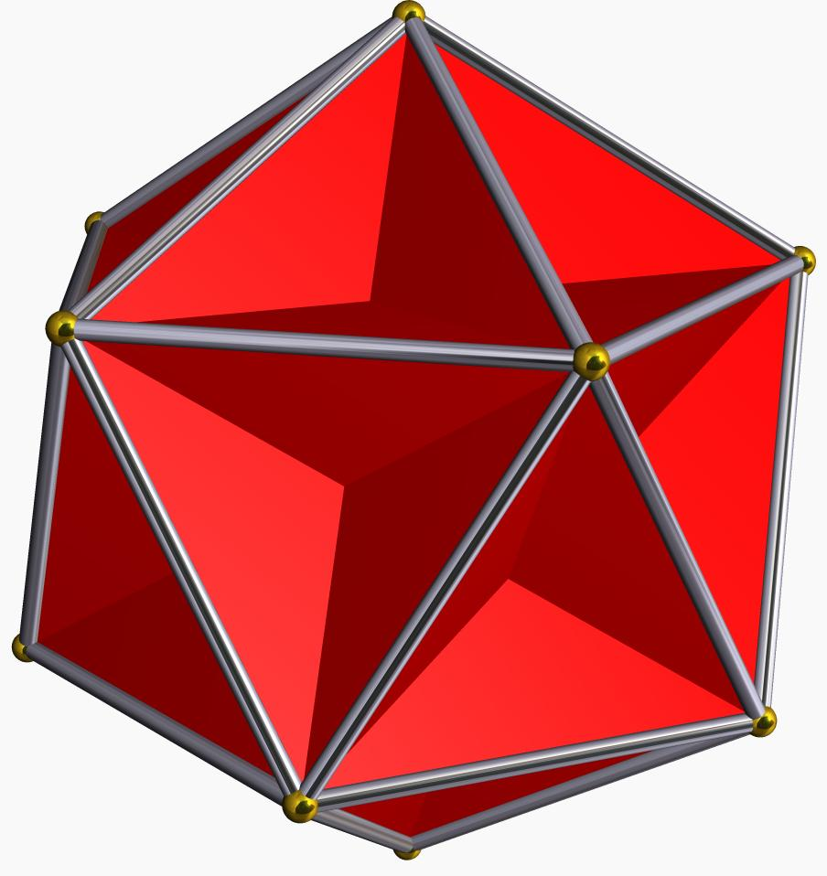
- Construct a regular pentagon using a compass and straightedge.
- Determine its center and construct its five equal sides.
- Use the regular icosahedron framework to establish the required positions of the twelve pentagonal faces.
- Construct five neighboring pentagonal face positions around each vertex of the framework.
- Connect the corresponding vertices to form the complete pentagonal face arrangement.
- Check that all twelve pentagons have equal side lengths and angles.
- Verify that five pentagonal faces meet at every true vertex.
- Complete the drawing by distinguishing the intersecting face regions.

Method 3: Construction Using a Paper Model
# Source: AI Source: Provided by: [Data Path: Persons Table -> ID Column: 1, Name_En Column: Motasem Essam] -> From: [ChatGPT] on [7/25/2026]
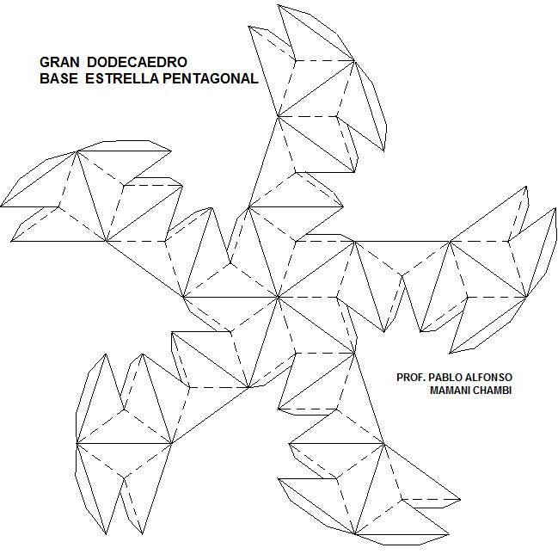
- Draw the 12 regular pentagonal faces with equal side lengths.
- Arrange the pentagons according to the vertex and edge relationships of the icosahedral framework.
- Mark the shared edges and their corresponding face connections.
- Prepare suitable tabs or joining strips where necessary.
- Cut out the pentagonal components.
- Assemble the components while preserving the intended intersecting face arrangement.
- Check that five faces meet at each of the twelve vertices.
- Adjust the connections to maintain the regularity and symmetry of the model.
Construction note: A conventional non-self-intersecting paper net cannot represent all the intersections of the great dodecahedron as an ordinary convex-polyhedron net. A physical model requires carefully arranged intersecting faces or a faceted framework.

Relationship to Other Geometric Solids

Small Stellated Dodecahedron
# Source: AI Source: Provided by: [Data Path: Persons Table -> ID Column: 1, Name_En Column: Motasem Essam] -> From: [ChatGPT] on [7/25/2026]
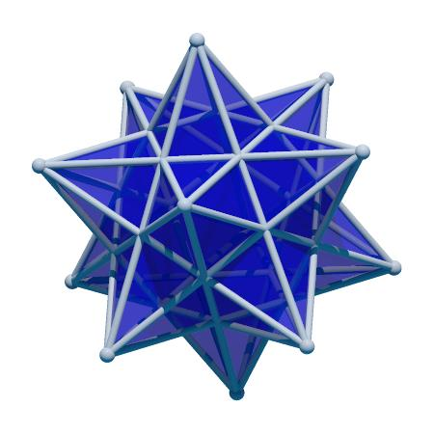
The Small Stellated Dodecahedron is the dual polyhedron of the Great Dodecahedron.
Their Schläfli symbols are related by reversing their parameters:
$$\{5,\frac{5}{2}\}longleftrightarrow\{\frac{5}{2},5\}$$
Their corresponding elements are:
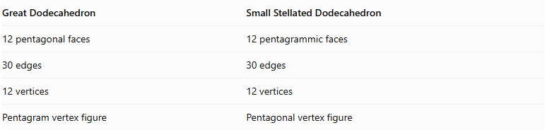
Great Dodecahedron | Small Stellated Dodecahedron
12 pentagonal faces | 12 pentagrammic faces
30 edges | 30 edges
12 vertices | 12 vertices
Pentagram vertex figure | Pentagonal vertex figure

Regular Icosahedron
# Source: AI Source: Provided by: [Data Path: Persons Table -> ID Column: 1, Name_En Column: Motasem Essam] -> From: [ChatGPT] on [7/25/2026]
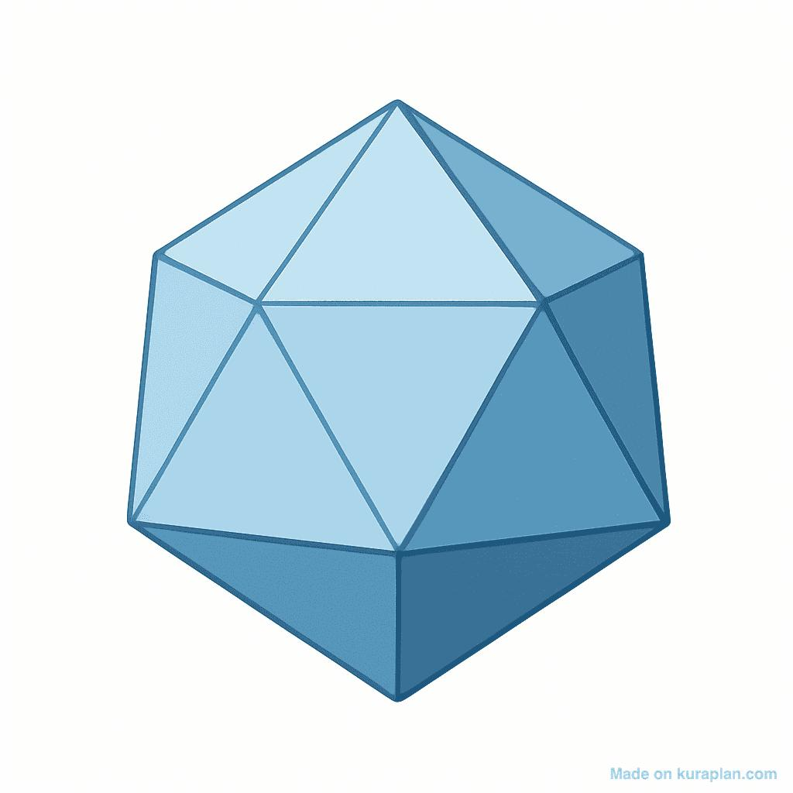
The Great Dodecahedron can be constructed by faceting a regular icosahedron.
Both solids have:
- 12 vertices.
- 30 edges.
- The same underlying edge graph.
However, the Great Dodecahedron uses 12 intersecting pentagonal faces instead of the 20 triangular faces of the icosahedron.

Regular Dodecahedron
# Source: AI Source: Provided by: [Data Path: Persons Table -> ID Column: 1, Name_En Column: Motasem Essam] -> From: [ChatGPT] on [7/25/2026]
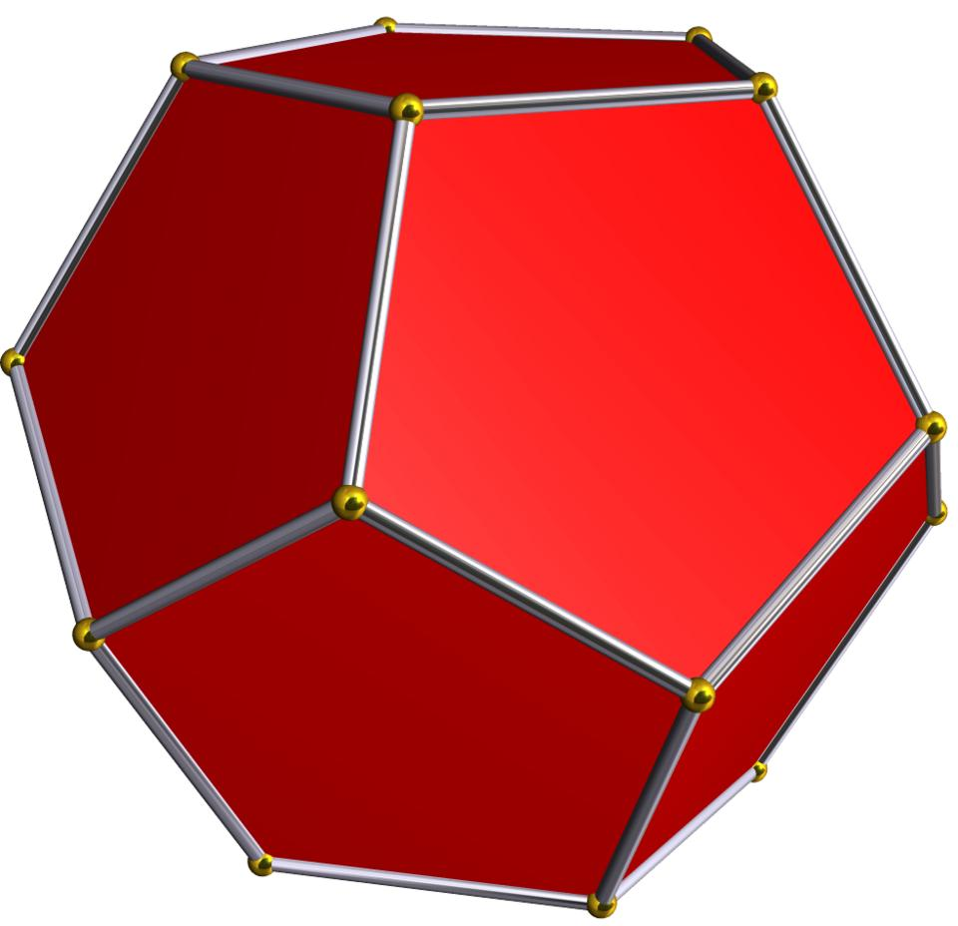
Both solids contain 12 regular pentagonal faces, but their face arrangements are different.
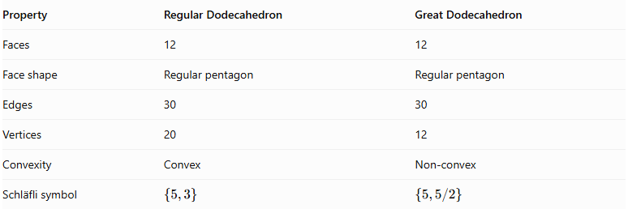
Property | Regular Dodecahedron | Great Dodecahedron
Faces | 12 | 12
Face shape | Regular pentagon | Regular pentagon
Edges | 30 | 30
Vertices | 20 | 12
Convexity | Convex | Non-convex
Schläfli symbol | $$\{5,3\}$$ | $$\{5,5/2\}$$

Comparison with Other Kepler–Poinsot Polyhedra
# Source: AI Source: Provided by: [Data Path: Persons Table -> ID Column: 1, Name_En Column: Motasem Essam] -> From: [ChatGPT] on [7/25/2026]
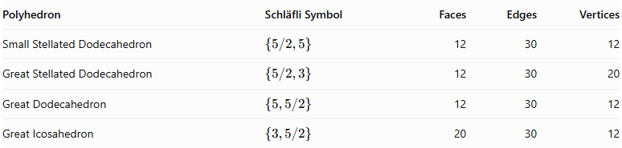
Polyhedron | Schläfli Symbol | Faces | Edges | Vertices
Small Stellated Dodecahedron | $$\{5/2,5\}$$ | 12 | 30 | 12
Great Stellated Dodecahedron | $$\{5/2,3\}$$ | 12 | 30 | 20
Great Dodecahedron | $$\{5,5/2\}$$ | 12 | 30 | 12
Great Icosahedron | $$\{3,5/2\}$$ | 20 | 30 | 12

Historical Background
# Source: AI Source: Provided by: [Data Path: Persons Table -> ID Column: 1, Name_En Column: Motasem Essam] -> From: [ChatGPT] on [7/25/2026]
- Johannes Kepler: Studied regular star polyhedra in the early seventeenth century.
- Louis Poinsot: Rediscovered and investigated the regular star polyhedra in 1809, including the Great Dodecahedron.
- Schläfli: Developed the notation used to represent regular polyhedra, including star polyhedra.
- The Great Dodecahedron is one of the four solids now collectively called the Kepler–Poinsot polyhedra.

Main Classification
# Source: AI Source: Provided by: [Data Path: Persons Table -> ID Column: 1, Name_En Column: Motasem Essam] -> From: [ChatGPT] on [7/25/2026]
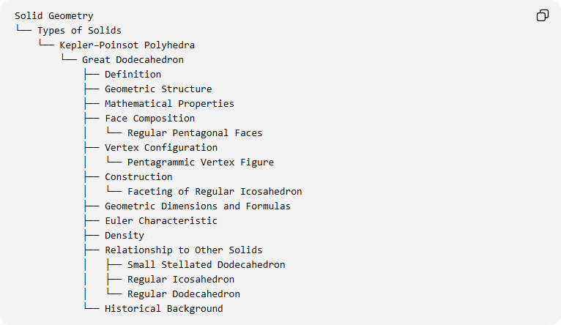
Solid Geometry
└── Types of Solids
└── Kepler–Poinsot Polyhedra
└── Great Dodecahedron
├── Definition
├── Geometric Structure
├── Mathematical Properties
├── Face Composition
│ └── Regular Pentagonal Faces
├── Vertex Configuration
│ └── Pentagrammic Vertex Figure
├── Construction
│ └── Faceting of Regular Icosahedron
├── Geometric Dimensions and Formulas
├── Euler Characteristic
├── Density
├── Relationship to Other Solids
│ ├── Small Stellated Dodecahedron
│ ├── Regular Icosahedron
│ └── Regular Dodecahedron
└── Historical Background

Key Points
# Source: AI Source: Provided by: [Data Path: Persons Table -> ID Column: 1, Name_En Column: Motasem Essam] -> From: [ChatGPT] on [7/25/2026]
- The Great Dodecahedron is one of the four Kepler–Poinsot polyhedra.
- It consists of 12 regular pentagonal faces.
- Five faces meet at each vertex in a pentagrammic arrangement.
- Its Schläfli symbol is $\{5,5/2\}$.
- It has 30 edges and 12 vertices.
- Its density is 3.
- Its dual is the Small Stellated Dodecahedron.
- It can be constructed by faceting a regular icosahedron.
- It is a regular non-convex polyhedron, not an irregular polyhedron.

Conclusion
# Source: AI Source: Provided by: [Data Path: Persons Table -> ID Column: 1, Name_En Column: Motasem Essam] -> From: [ChatGPT] on [7/25/2026]
The Great Dodecahedron is a regular non-convex polyhedron distinguished by its 12 intersecting pentagonal faces and pentagrammic vertex arrangement. Its dual relationship with the Small Stellated Dodecahedron and its construction through the faceting of an icosahedron make it an important member of the Kepler–Poinsot family.

